**CI/CD Project – 2**

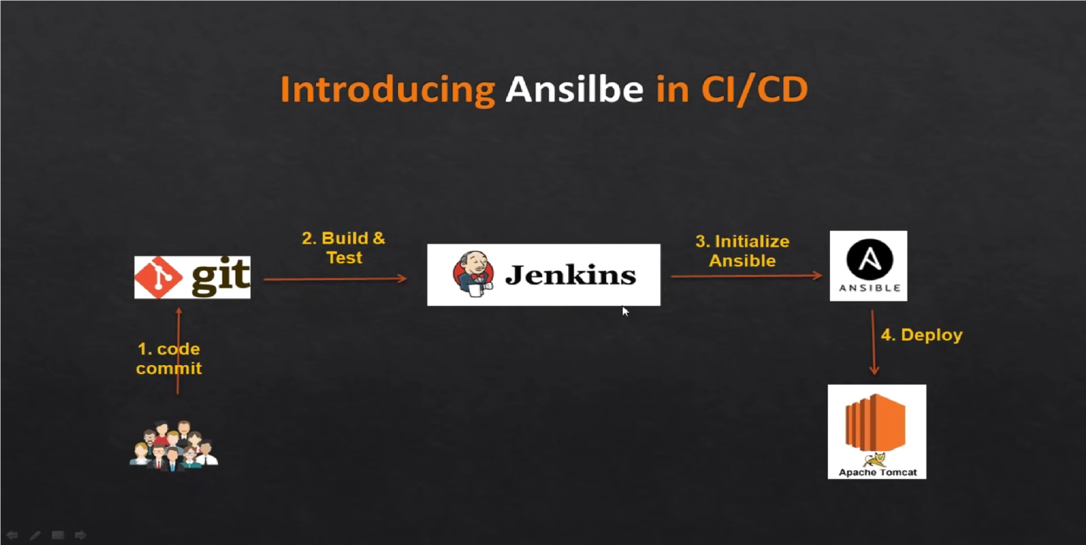

**Created 3 EC2 instance for this task.**

1. **Configured first EC2 instance and as Ansible server**

Configured Ansible as MasterNode.

Created User – ansiblecontrol and did all necessary configuration for the ansiblecontrol user.

sudo useradd -s /bin/bash -m -d /home/ ansiblecontrol -c "Ansible User" ansiblecontrol

1. **Configured second EC2 instance as Tomcat server**

Configured Tomcat as SlaveNode.

Created User – managedhost and did all necessary configuration.

sudo useradd -s /bin/bash -m -d /home/managedhost -c "Ansible User" managedhost

1. **Configured third EC2 instance as Jenkins server**

**Part 1:**

**Performed Integration steps on Jenkins**

1. Installed “Publish over SSH” plugins
2. Enable connection between Ansible and Jenkins

- `Manage Jenkins` > `Configure System` > `Publish Over SSH` > `SSH Servers` - SSH Servers:

- Hostname: ` 10.0.1.253` (Provided Private IP of the Ansible Master)

- username: ansiblecontrol

3. Test the connection

**Part 2:**

1. Created a Playbook on Ansible Master.
2. Created copywarfile.yml on Ansible Master under /opt/playbooks

# copywarfile.yml

---

- hosts: all

become: true

tasks:

- name: copy jar/war onto tomcat servers

copy:

src: /opt/playbooks/webapp/target/webapp.war

dest: /opt/tomcat/webapps

1. Added tomcat server details to /etc/ansible/hosts on Ansible Master

echo 10.0.1.70 /etc/ansible/hosts (Private_IP of Tomcat)

**Part 3:**

Created a Job on Jenkins servers

- *Source Code Management:*

- Repository: `https://github.com/BPatel86/CI-CD-Pipeline-2.git`

- Branches to build : `*/main`

- *Build:*

- Root POM:`pom.xml`

- Goals and options : `clean install package`

- *Add post-build steps*

- Send files or execute commands over SSH

- SSH Server : `Ansible`

- Source files: `webapp/target/*.war`

- Remote directory: `//opt//playbooks`

- *Add post-build steps*

- Send files or execute commands over ssH

- SSH Server : `Ansible`

- Exec command: ansible-playbook /opt/playbooks/copywarfile.yml

**After the Job execution was successful, the build was successfully deployed on Tomcat server in “Application Manager” under “List Applications”**

